Ref. No.: IVM/KBIPER/TPC/IV/2024-25/01 Date: 24/08/2024

REPORT

01 | Date of activity | 23/08/2024, Friday
02 | Total attendance | 64 Students
03 | Occasion of activity | Industrial visit to “MAGS IATRC Research and Training Pvt. Ltd.”
04 | Platform | Offline mode
 | Objective | To provide guidance to students about industry, information about guidelines, work culture, documentation, etc.
06 | No. of Persons Visited from College | 1. Prof. Shyam S. Awate.  2. Prof. Shraddha S. Satkar  3. Prof. Amol S. Deshmukh
07 | Responsible person from industry | Dr. Sandesh Kate, Director & Mr. Govind Deshpande, Director, MAGS IATRC Research and Training Pvt. Ltd. Bhosari, Pune. Maharashtra- 411026.
08 | Summary Industrial visit  Indrayani Vidya Mandir’s Krishnarao Bhegade Institute of Pharmaceutical Education and Research, organized an industrial visit to MAGS IATRC Research and Training Pvt. Ltd. on 23/08/2024, Friday. Dr. Sandesh Kate, heartily welcomed staff and students of Final Year B. Pharmacy. Prof. Awate sir instructed the students regarding rules and regulation of industry. The students had been divided in two batches.  Dr. Sandesh Kate sir gave a presentation of the instruments available in the lab and their importance in research. MAGS IATRC Research and Training Pvt. Ltd. is one of the emerging, global, independent market leaders providing hands-on training on various analytical instruments.  Dr. Sandesh Kate and Mr. Ashish gave information on the following instruments to each batch of students.  - UV Spectrophotometer  - Gas Chromatography  - Dissolution apparatus  - Disintegration test apparatus  - Karl Fisher apparatus &  - HPLC  The students had enjoyed the activity with actual experience of industrial visit. The session concluded with a question and answer.  The Overall session was informative and motivational.  The vote of thanks was given by Prof. Amol S. Deshmukh
09 | Activity co-coordinator | 1. Prof. Shyam S. Awate.  2. Prof. Shraddha S. Satkar  3. Prof. Amol S. Deshmukh

Prof. Shyam S. Awate
Dean Training and placement III ED cell Dr. Sanjay R. Arote
Email ID: placement.iiper@gmail.com Principal
Mob: 9545713667

Ref. No.: IVM/KBIPER/TPC/IV/2024-25/01 Date: 24/08/2024

Geotag photos of Industrial visit
Dr. Sandesh Kate Giving information of their research facility to the students
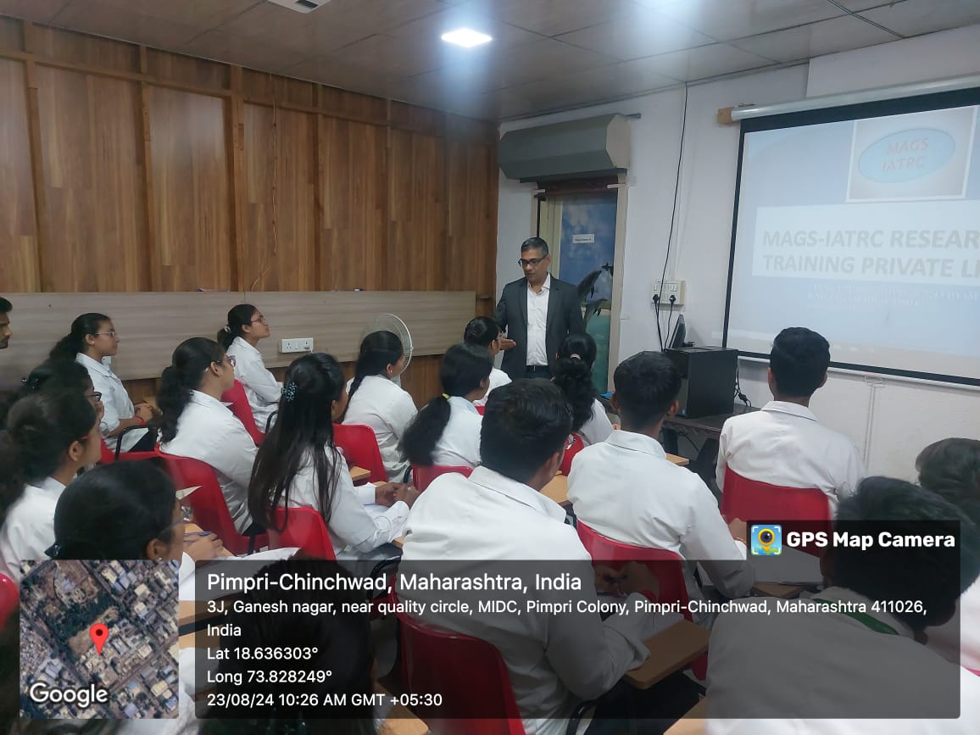 | 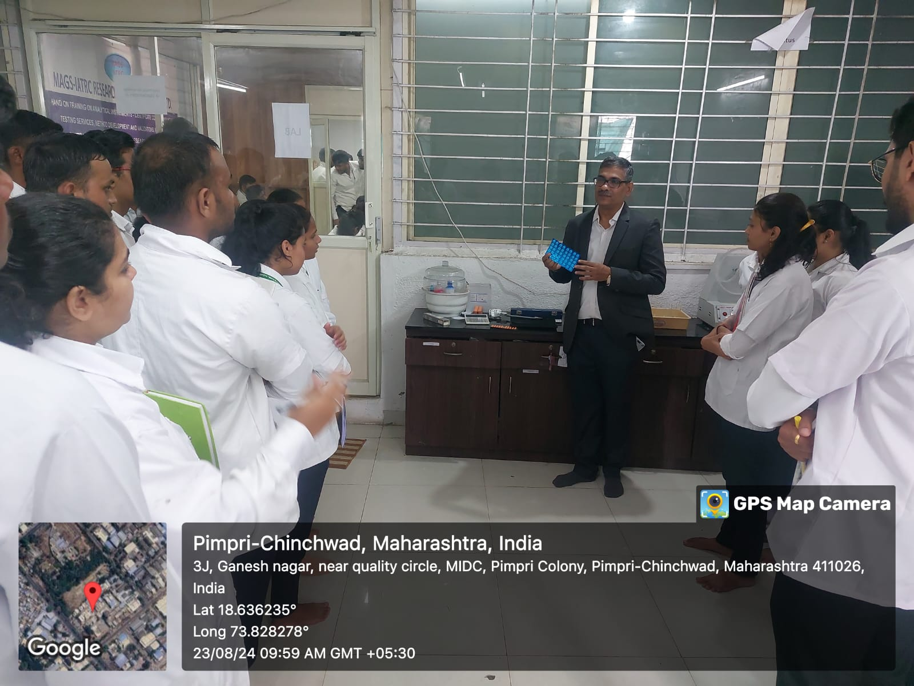
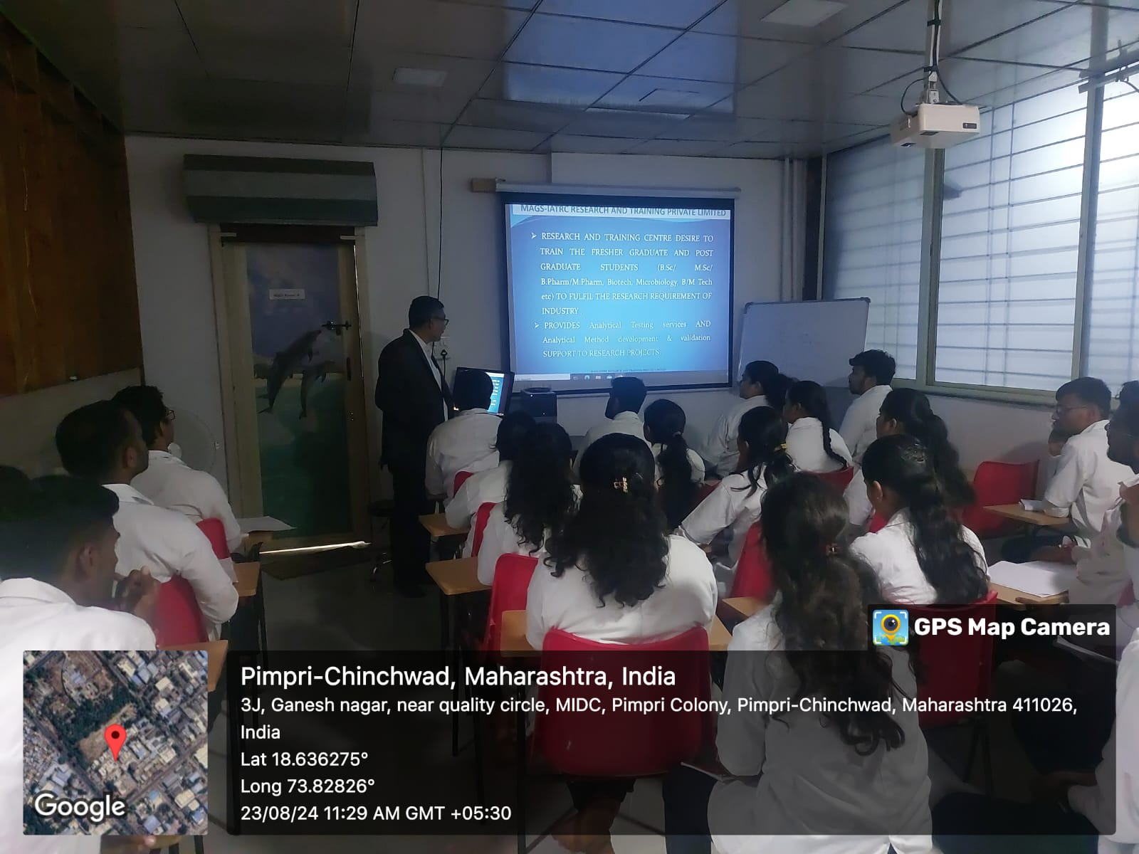 | 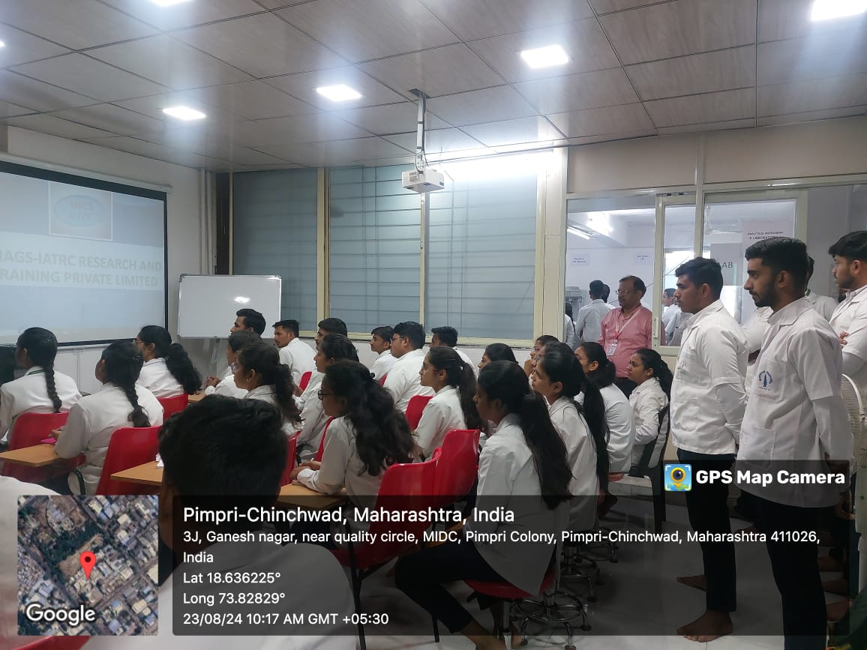
Students engrossed in the demonstration
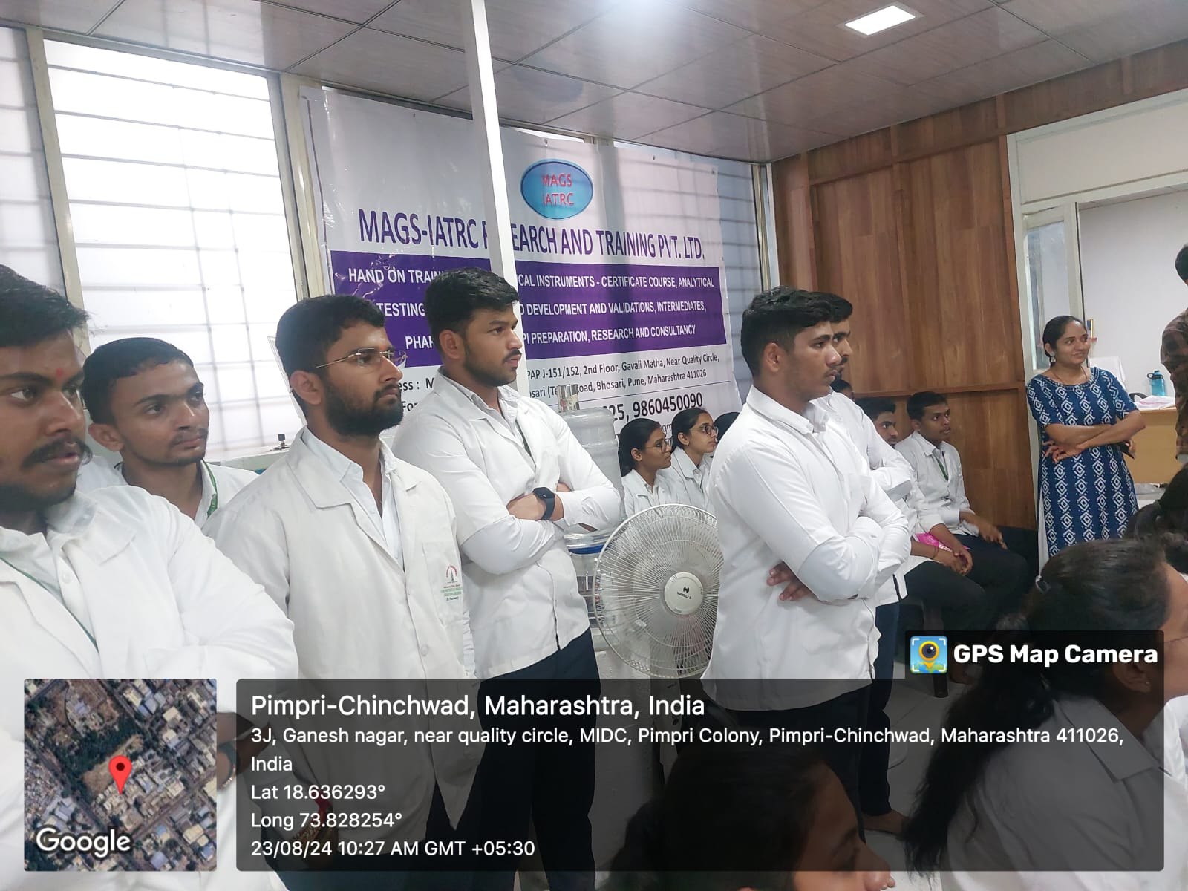 | 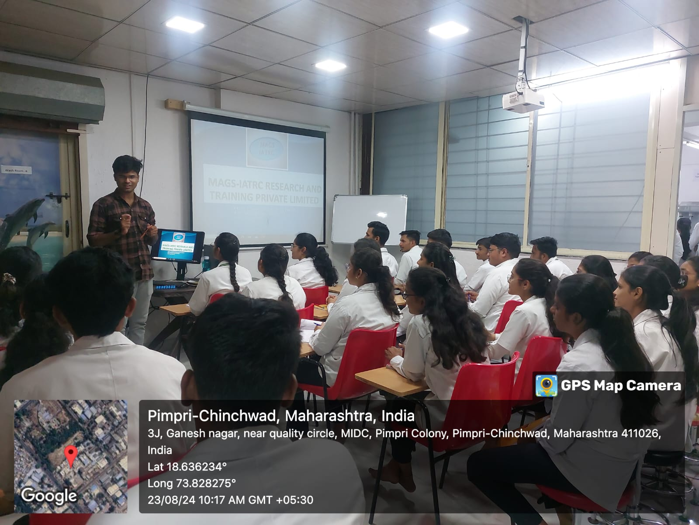
All staff members with Dr. Sandesh Kate
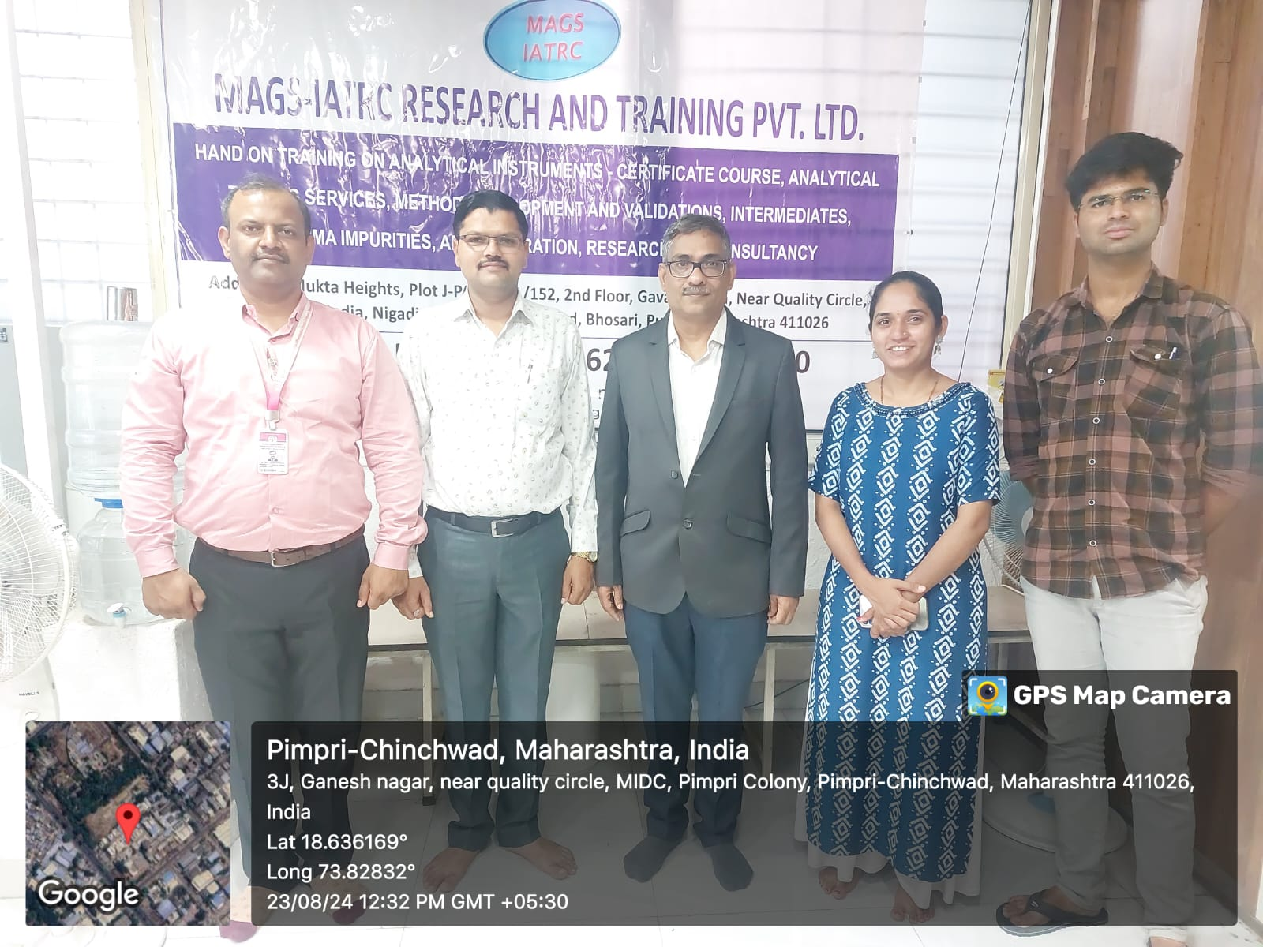

Prof. Shyam S. Awate Dr. Sanjay R. Arote
Dean Training and placement III ED cell Principal
Email ID: placement.iiper@gmail.com
Mob: 9545713667

